WEEK-4

Spring Rest Hands-on

**Exercise-1: Hello World RESTful Web Service**

**src/main/java/com/cognizant/spring_learn/controller/HelloController.java**

package com.cognizant.spring_learn.controller;

import org.slf4j.Logger;

import org.slf4j.LoggerFactory;

import org.springframework.web.bind.annotation.GetMapping;

import org.springframework.web.bind.annotation.RestController;

@RestController

public class HelloController {

private static final Logger LOGGER = LoggerFactory.getLogger(HelloController.class);

@GetMapping("/hello")

public String sayHello() {

LOGGER.info("START - sayHello()");

String message = "Hello World!!";

LOGGER.debug("Message: {}", message);

LOGGER.info("END - sayHello()");

return message;

}

}

**src/main/resources/application.properties:**

spring.application.name=spring_learn

server.port=8083

logging.level.org.springframework=info

logging.level.com.cognizant.spring_learn=debug

logging.pattern.console=%d{yyMMdd}|%d{HH:mm:ss.SSS}|%-20.20thread|%5p|%-25.25logger{25}|%25M|%m%n

**SpringLearnApplication.java:**

package com.cognizant.spring_learn;

import org.slf4j.Logger;

import org.slf4j.LoggerFactory;

import org.springframework.boot.SpringApplication;

import org.springframework.boot.autoconfigure.SpringBootApplication;

@SpringBootApplication

public class SpringLearnApplication {

private static final Logger LOGGER = LoggerFactory.getLogger(SpringLearnApplication.class);

public static void main(String[] args) {

LOGGER.info("START - SpringLearnApplication main()");

SpringApplication.run(SpringLearnApplication.class, args);

LOGGER.info("END - SpringLearnApplication main()");

}

}

**OUTPUT:**

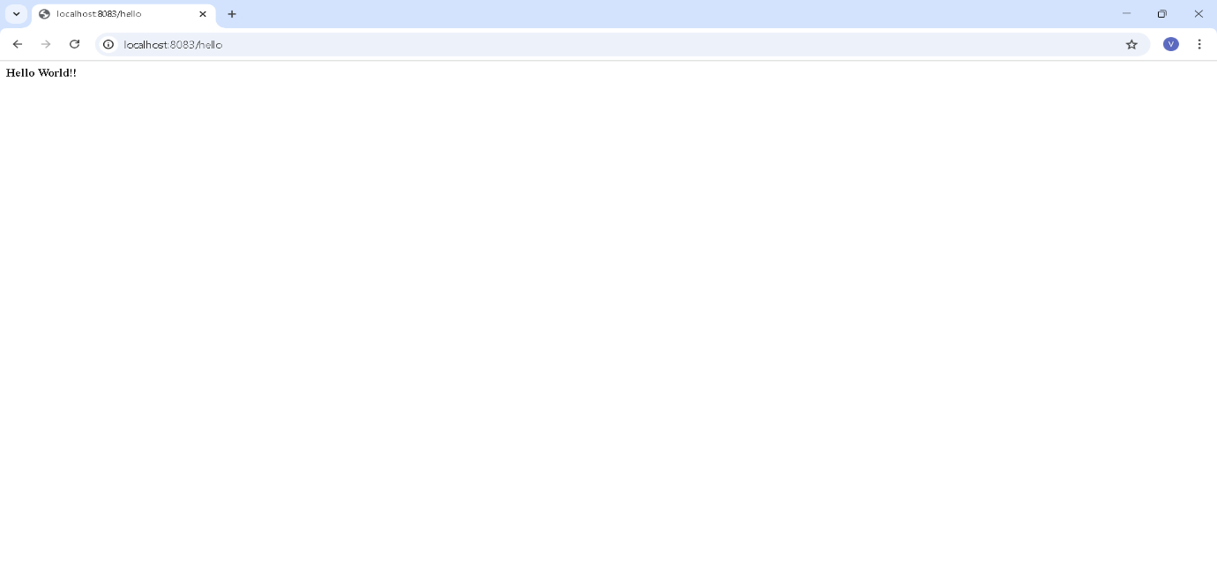

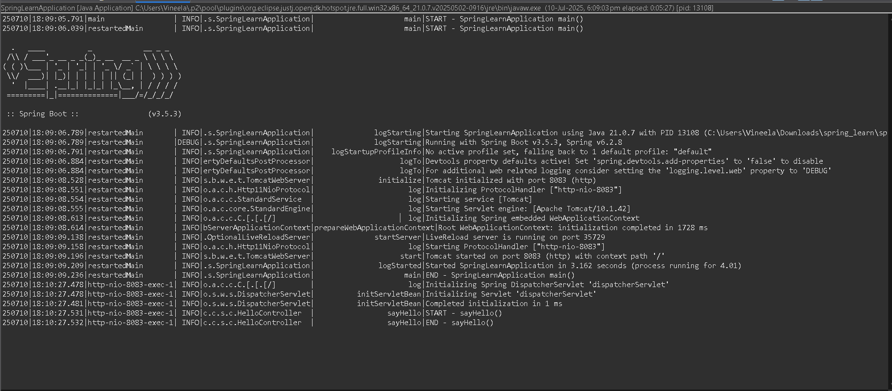

**Exercise-2: REST - Country Web Service**

**src/main/java/com/cognizant/spring_learn/controller/CountryController.java:**

package com.cognizant.spring_learn.controller;

import com.cognizant.spring_learn.Country;

import org.slf4j.Logger;

import org.slf4j.LoggerFactory;

import org.springframework.context.ApplicationContext;

import org.springframework.context.support.ClassPathXmlApplicationContext;

import org.springframework.web.bind.annotation.RequestMapping;

import org.springframework.web.bind.annotation.RestController;

@RestController

public class CountryController {

private static final Logger LOGGER = LoggerFactory.getLogger(CountryController.class);

@RequestMapping("/country")

public Country getCountryIndia() {

LOGGER.info("START - getCountryIndia()");

ApplicationContext context = new ClassPathXmlApplicationContext("country.xml");

Country country = context.getBean("country", Country.class);

LOGGER.debug("Country: {}", country);

LOGGER.info("END - getCountryIndia()");

return country;

}

}

**src/main/resources/application.properties:**

spring.application.name=spring_learn

server.port=8085

logging.level.org.springframework=info

logging.level.com.cognizant.spring_learn=debug

logging.pattern.console=%d{yyMMdd}|%d{HH:mm:ss.SSS}|%-20.20thread|%5p|%-25.25logger{25}|%25M|%m%n

**src/main/resources/country.xml:**

<?xml version="1.0" encoding="UTF-8"?>

<beans xmlns="http://www.springframework.org/schema/beans"

xmlns:xsi="http://www.w3.org/2001/XMLSchema-instance"

xsi:schemaLocation="http://www.springframework.org/schema/beans

https://www.springframework.org/schema/beans/spring-beans.xsd">

<bean id="country" class="com.cognizant.spring_learn.Country">

<property name="code" value="IN" />

<property name="name" value="India" />

</bean>

</beans>

**OUTPUT:**

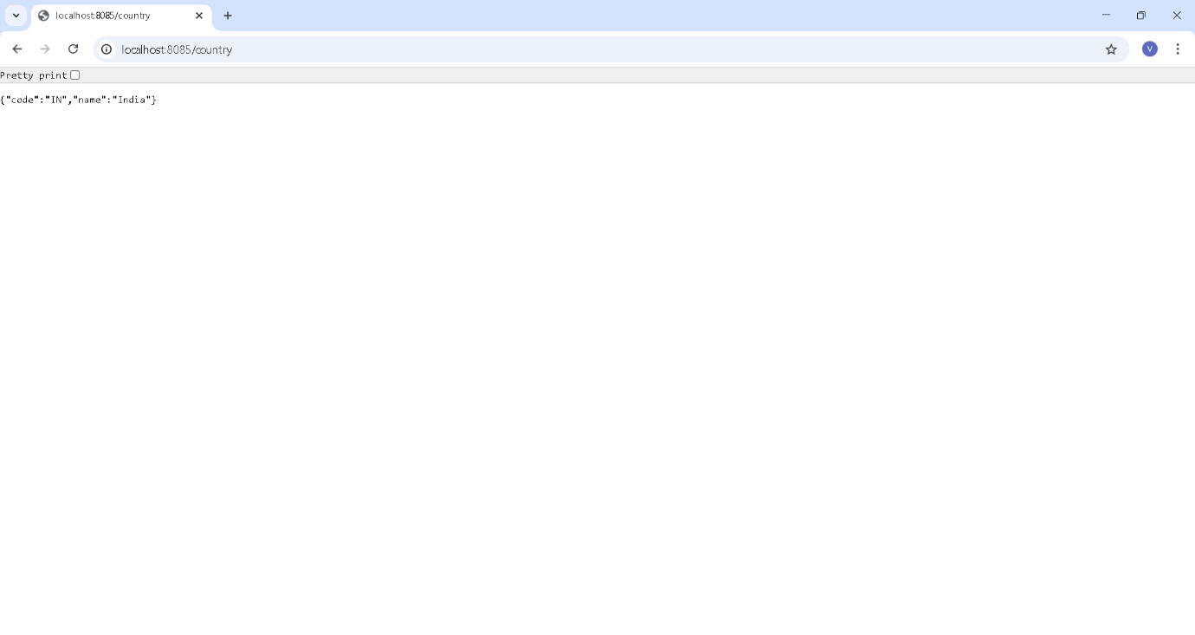

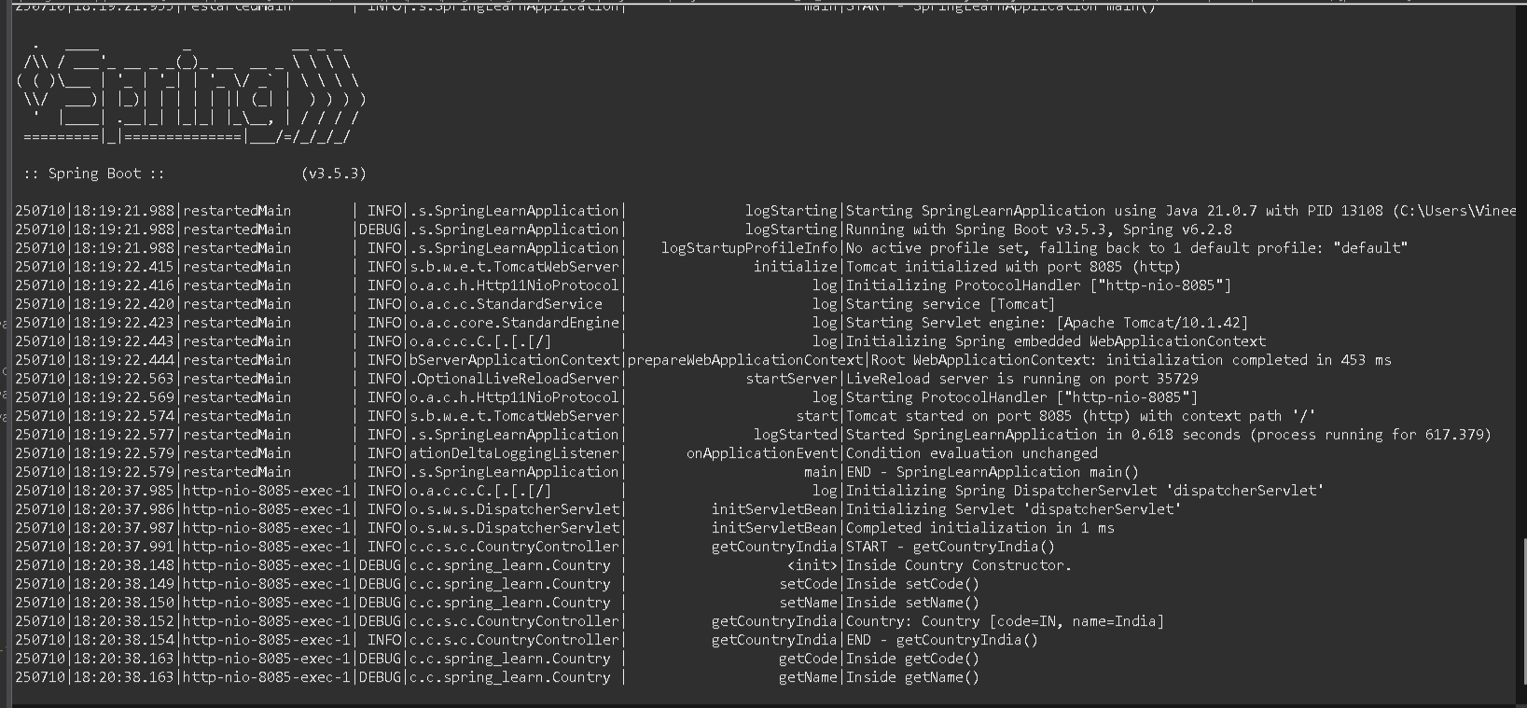

**Exercise-3: REST - Get country based on country code**

**src/main/resources/country.xml:**

<beans xmlns="http://www.springframework.org/schema/beans"

xmlns:xsi="http://www.w3.org/2001/XMLSchema-instance"

xsi:schemaLocation="http://www.springframework.org/schema/beans

https://www.springframework.org/schema/beans/spring-beans.xsd">

<bean id="in" class="com.cognizant.spring_learn.Country">

<property name="code" value="IN" />

<property name="name" value="India" />

</bean>

<bean id="us" class="com.cognizant.spring_learn.Country">

<property name="code" value="US" />

<property name="name" value="United States" />

</bean>

<bean id="de" class="com.cognizant.spring_learn.Country">

<property name="code" value="DE" />

<property name="name" value="Germany" />

</bean>

<bean id="jp" class="com.cognizant.spring_learn.Country">

<property name="code" value="JP" />

<property name="name" value="Japan" />

</bean>

<bean id="countryList" class="java.util.ArrayList">

<constructor-arg>

<list>

<ref bean="in"/>

<ref bean="us"/>

<ref bean="de"/>

<ref bean="jp"/>

</list>

</constructor-arg>

</bean>

</beans>

**CountryController.java:**

package com.cognizant.spring_learn.controller;

import org.springframework.web.bind.annotation.RestController;

import org.springframework.web.bind.annotation.GetMapping;

import org.springframework.web.bind.annotation.PathVariable;

import org.springframework.web.bind.annotation.RequestMapping;

import org.springframework.beans.factory.annotation.Autowired;

import org.slf4j.Logger;

import org.slf4j.LoggerFactory;

import com.cognizant.spring_learn.Country;

import com.cognizant.spring_learn.service.CountryService;

@RestController

public class CountryController {

private static final Logger LOGGER = LoggerFactory.getLogger(CountryController.class);

@Autowired

private CountryService countryService;

@RequestMapping("/country")

public Country getCountryIndia() {

LOGGER.info("START - getCountryIndia()");

Country country = countryService.getCountry("IN");

LOGGER.info("END - getCountryIndia()");

return country;

}

@GetMapping("/countries/{code}")

public Country getCountry(@PathVariable String code) {

LOGGER.info("START - getCountry()");

Country country = countryService.getCountry(code);

LOGGER.info("END - getCountry()");

return country;

}

}

**src/main/java/com/cognizant/spring_learn/service/CountryService.java:**

package com.cognizant.spring_learn.service;

import com.cognizant.spring_learn.Country;

import org.slf4j.Logger;

import org.slf4j.LoggerFactory;

import org.springframework.context.ApplicationContext;

import org.springframework.context.support.ClassPathXmlApplicationContext;

import org.springframework.stereotype.Service;

import java.util.List;

@Service

public class CountryService {

private static final Logger LOGGER = LoggerFactory.getLogger(CountryService.class);

public Country getCountry(String code) {

LOGGER.info("START - getCountry()");

ApplicationContext context = new ClassPathXmlApplicationContext("country.xml");

List<Country> countries = context.getBean("countryList", List.class);

Country result = countries.stream()

.filter(c -> c.getCode().equalsIgnoreCase(code))

.findFirst()

.orElse(null);

LOGGER.info("END - getCountry()");

return result;

}

}

**OUTPUT:**

